**CS 135 Final Project Report**

Junyoung Kwon

Bradley Hayes

Reed Kanemaru

**Youtube Link**

[**https://www.youtube.com/watch?v=7CR2djpRL_w**](https://www.youtube.com/watch?v=7CR2djpRL_w)

**Abstract**

Our VR project is a collection of short mazes that gradually increase in difficulty as you progress between them. In order to exit each maze, you must find each stages’ treasure chest in order to open its door. We tried to make the experience unique by having the walls and halls of the maze rather large, making the player feel small and isolated. We also wanted to create different vignettes for the player’s experience, giving the player a different kind of feeling as they enter each stage. The progression between stages introduces the basics -> introducing false chests -> introducing platforming. The “meta-game” of the project emphasizes memorizing the mazes by giving the player their clear time, giving them a chance to embrace their competitive side.

**Introduction**

As stated, this project is a collection of short, separate mazes that have their own distinct identity in appearance and function. The first maze serves as an introduction to the basic mechanics: to keep their ears open to find the treasure chest to unlock the door, and to find the exit. The first wall the user sees instructs the player the controls as well as informing them to find the chest before trying to leave. They will be able to tell if they are getting close to the treasure chest, based on a looping sound clip. This way they won’t be entirely clueless when searching for something besides the door. If they find the exit before the chest, there will be a massive door blocking their way.

The second maze will up the difficulty by having several chests hidden inside. The catch is that there is only one correct chest. This means the player can open a false chest, which will have a unique sound effect, distinguishing itself from the correct chest. This gives the player another type of audio cue that is required for them to keep their ears open for, ultimately serving as a progression of what the user has learned so far. The maze itself is of similar difficulty, but having the user potentially exploring more corners to find the correct chest may cause them to get lost more easily, since they’ve spent more time inside. However, the chests aren’t placed too far out of the way from the correct path for them to get too turned-around.

The third and final maze uses the same mechanics as the previous two mazes, but utilizes another tool in the user’s kit. Pressing ‘F’ allows the user to jump, which will be necessary to reach the exit of this maze. There were two false chests and one real chest inside of this maze, each requiring the user to clear platform-jumping challenges to access them. Of course the false chests will not open the door, but for the sake of consistency, the user will have to be working to open them as well. The platforming challenges are designated for each chest, and come in the form of two stair-like patterns, one being a straightaway, and one being a spiral sort of shape. The final platforming challenge requires diagonally hopping between platforms, focusing more on distance than height. The platforming itself is simple and not especially difficult, but throwing a new movement-based mechanic into the user’s hand will provide them to traverse the maze differently than before, and with VR it may be a bit more daunting to jump from a large height. The “finish line” is a small room that displays completion text and a cleartime. The goal is for the user to replay the game and memorize the maze to improve their time.

**Related Works**

There are multiple types of VR mazes, with one example coming to mind being “VR Maze Walk” for Google Cardboard. This game has the player traversing through a castle-like maze, which leads to a tower. The climbing of the tower itself is very simple, just consisting of a stair climb. When the player reaches the top of the tower, they will have completed the maze. While the complexity of the maze and its mechanics are not particularly notable, the fact that it was able to be usable on Google Cardboard is impressive in itself. The platform it is played on does come with drawbacks of its own. Mainly that the means of movement is to bob the user’s head while facing their desired direction of movement. The tower being visible over the maze walls makes solving the maze much easier, and gives the player a consistent point of reference in case they get lost, which is not implemented in our maze, since we placed a ceiling on the entirety of the maze. Compared to our project, this one shows more polish aesthetically, but is rather simple, and is unwieldy for the player to control.

Another VR maze is called World of Mazes, which has a fantasy setting, with fiery dungeons and mystical forests being the locales where you explore. This project appears to be very ambitious, as it seems to include many NPCs that the user can encounter, including allys and enemies. There seems to have been a lot of effort put into the character models and the aesthetics of the dungeons themselves. There seemed to be more conventional game mechanics, such as shopkeepers you can meet within the mazes. This game was made for the Oculus Go, so the graphics are limited. The developers made the most of what they had to make their VR maze go above and beyond what could be described as a maze.

A VR maze that breaks ground with what could be defined as a maze is found on a YouTube video called “VR Maze Game - Trilomaze (Concept)” which gives an overview of a maze project made in Unity. The concept is a space maze, split into 7 different small stages, each with their own puzzles that interact with different components in other stages. To traverse between stages, the user travels through one of three teleportation devices that are found on each stage. Each of these teleportation devices lead to a different destination, causing the user to easily get lost on which stage they are currently on. This maze game is extremely creative in creating an unconventional method of giving the user the same kind of confusion that a regular maze can give. The concept is extremely interesting, and the implementation is stellar.

**Implementation**

To this project, there are three main function scripts: Timer, Chest, and Fake_Chest.

The Timer Script is designed for one the main objectives of the game; the objective is to clear the game in the fastest time possible. As a result, we needed to design a function that would allow us to keep track of the time when the user starts the game until the user reaches the finish. To explain further, once the user starts the game, the timer - initially set at 0 seconds - starts counting up. Once the user sets foot in the finish room, the timer stops and whatever time the timer stops at is displayed.

The Chest Script is designed for the chests with the keys lying around in the mazes. The Chest Script passes in two GameObjects: chestOpen and door. Throughout the map, the user will hear a noise indicating there is a chest nearby. As the user gets near the chest, the sound will get louder. Once the user collides with the box collider on the chest, as the code states, the sound turns off, the Mesh_Renderer for the chestOpen becomes enabled, and the Mesh_Renderer for the current closed chest becomes disabled. With this, the user hears a ding indicating the key was obtained. At the same time, the door preventing the user from advancing to the next level, disappears.

The Fake_Chest Script is very similar to the Chest Script with just a couple differences. Starting from the second and the third maze, we introduced a new obstacle called Fake Chests in which the fake and the real ones look and sound identical; however, the fake one does not give you the key. To further explain, when the user approaches a fake chest, it will emit the same sound as it would with the real chest. Once the user collides with the box collider on the chest, as the code states, the sound turns off, the Mesh_Renderer for the chestOpen becomes enabled, and the Mesh_Renderer for the current closed chest becomes disabled. However, the script plays a different sound indicating the user was not able to get the key, and the door preventing the user from advancing to the next level is still present. This script provides a unique challenge that has a surprising element to the user, frustrating them.

**Design**

For our maze we have three separate mazes with different designs and game mechanics all linked together.

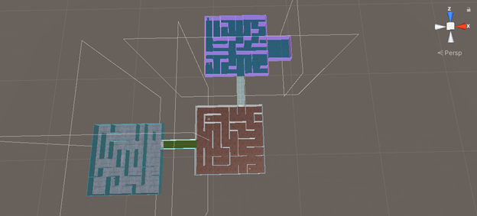

While not pictured above, there is a ceiling that covers all the mazes and hallways between the mazes. However, the ceiling looks like an ashen sky.

Between the mazes there are hallways that separate the different mazes.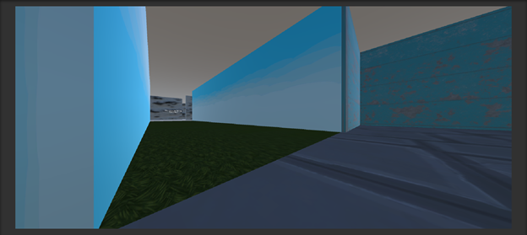

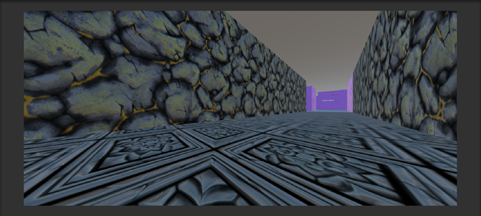

In the first maze, the controls are written along the walls inside the first maze. There is also just a simple chest with a key to look for to open the hallway to the second maze.

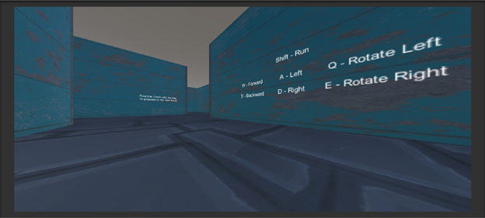

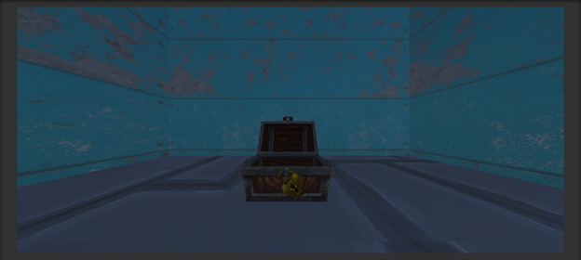

In the second maze, there are fake chests so the player must find the correct one.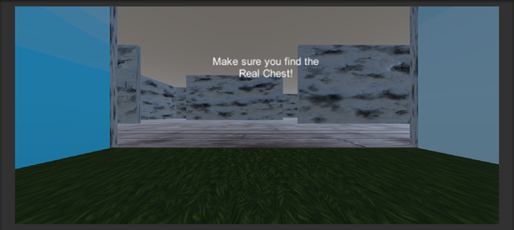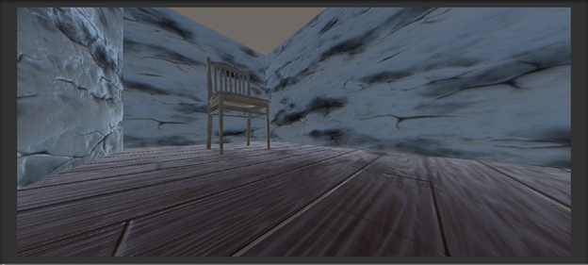 In the third maze, there are fake chests and platforms are added to the maze as well.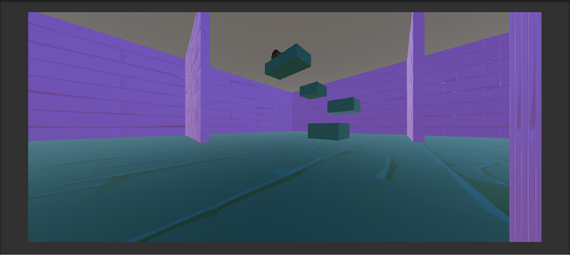

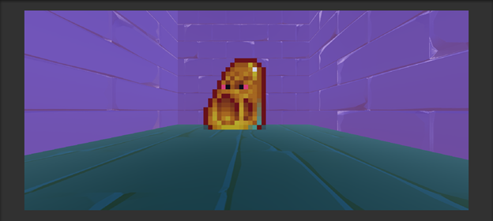

Finally, after completing the three mazes the finish displays the time it took to complete all three mazes.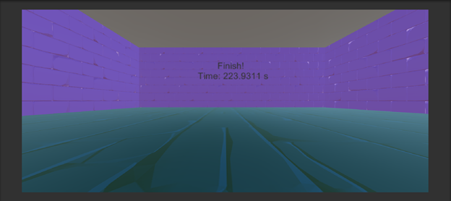 Initially, we were using the Oculus Touch to help immerse the player within the maze. However, because we could not use the headset for the video, the controls were changed to keyboard.

The Oculus Touch had initial controls that were available and made it easy to implement into the maze. When we transitioned the controls to use just the keyboard because the movement and looking around could be shifted to just use the keyboard.

Our project conforms to the Oculus Best Practices guide by not giving at least us, who created the game, eyestrain, disorientation, and nausea. Our game does not necessarily conform to the ability to take a break through pausing or save points, but our game is short enough where one session should not take too much time to complete. There can be discomfort from moving throughout the maze because the user is not physically moving themselves. For the most part, our project conforms to the Oculus Best Practices and created a good experience for us and Kevin.

Our design performs best when users are sitting to avoid disorienting themselves. When standing it does not get disorienting for us but everybody is different and it could be for other people. One important design we implemented was the progressive difficulty of the mazes. At first, we just had 3 mazes each with a chest to find. But, to make the game feel more progressive, it was changed to be harder as you completed each maze.

**Lessons Learned**

As we worked on our project, we learned the importance of having a progressive system incorporated into our game. After three mazes of the same objective with a different layout, the game felt stale. We ran into several issues with errors for unknown reasons, but by using some critical thinking, looking up errors on google, and asking Kevin we were able to solve these problems that we faced. For example, one problem included being able to look through walls if you moved just your head further forward. To fix this we tried creating a bigger box collider and making the walls thicker but none of that worked. We just decided to leave it because it is not an issue unless the player tries to move their head very far in front of their body. It isn’t something people will do through normal gameplay.

Because we were not able to demo to other people in the class we do not think it is appropriate to have an explanation in regards to the reaction to the project.

Our team worked together to finish the project. For the most part, Bradley worked on the maze layouts, Eric worked on implementing the mazes into the game, and Reed wrote the code. These were each of our main focuses, but we all helped each other with their work to have multiple opinions and perspectives. There was a lot of creative collaboration that resulted in the many ideas that are seen in our project. Bradley and Eric put the finishing touches by changing the mazes to be increasingly more difficult because Reed had prior obligations. While the current Coronavirus situation, it became difficult to work together on the project, but before that, we had been consistently hardworking and collaborative with each other.